Vulnerability 1
1. Vulnerability Name – Cross Site Scripting (XSS) in search field
2. Technical Description – “document.createElement('div').innerHTML = "<img src
onerror=alert()>" supposed to generate a blank pop up but generates a sign up for account link.
3. Proof of Concept
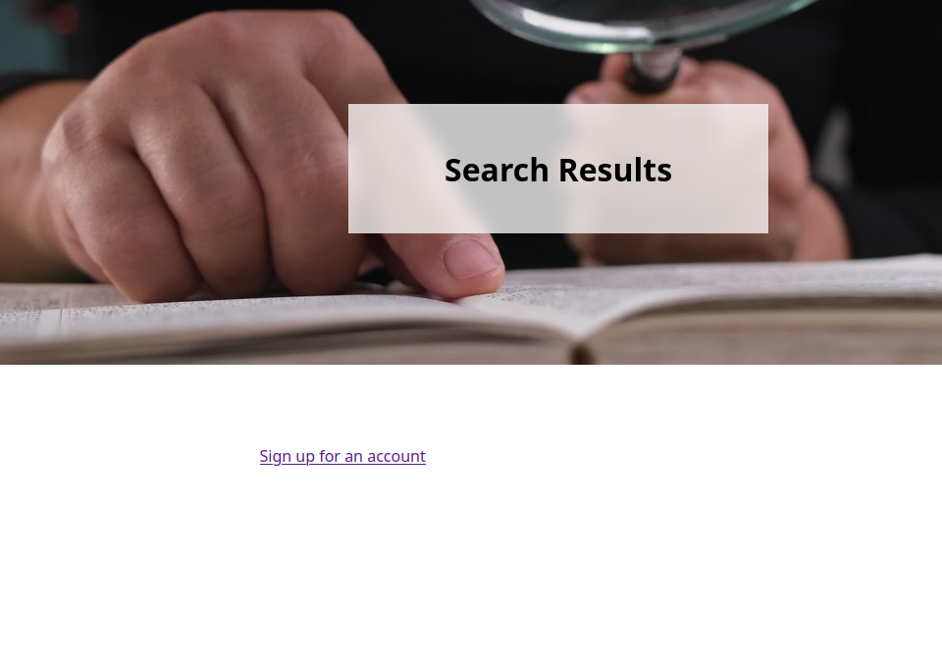
4. OWASP Category (with link) - A05:2025 - Injection A03 Injection -2021
5. CWE ID (with link) - CWE-79 https://cwe.mitre.org/data/definitions/79.html
6. Real-World Impact Scenario - A real-world scenario would be a website search bar that displays user input using inner HTML without filtering it. An attacker could enter a payload like <img src onerror=alert()>, which would execute JavaScript when the page loads. This is an example of a DOM-based cross-site scripting (XSS) attack that could allow attackers to steal session data or redirect users to malicious sites. DOM-based Cross-Site Scripting (DOM-based XSS) is a type of cross-site scripting attack where malicious code is executed in a user's browser because a website’s JavaScript modifies the DOM using untrusted input without properly validating or sanitizing it. The DOM (Document Object Model) is the structure that represents the elements of a webpage (HTML elements like buttons, forms, images, etc.).
7. Risk Severity – Very high, XSS payloads can be accepted by the website in the search field
8. Mitigation Strategy - The search field should only accept the types of characters that are necessary. For example, if the search field is meant for product names or keywords, the application can restrict input to letters, numbers, and basic punctuation. Blocking or filtering characters like <, >, ", and ' can help prevent script injection.
9. Sources / References - OWASP Top 10:2021 OWASP Top 10:2025 CWE - CWE List Version 4.19.1

Vulnerability 2
1. Vulnerability Name – Insecure Design, exposure of confidential account nickname information.
2. Technical Description – Double click on “Account Nickname” field in Admin dashboard and it states, (Reject unexpected characters like ‘, …’). This gives away typing in the characters (‘) and (…) will show more accounts.
3. Proof of Concept
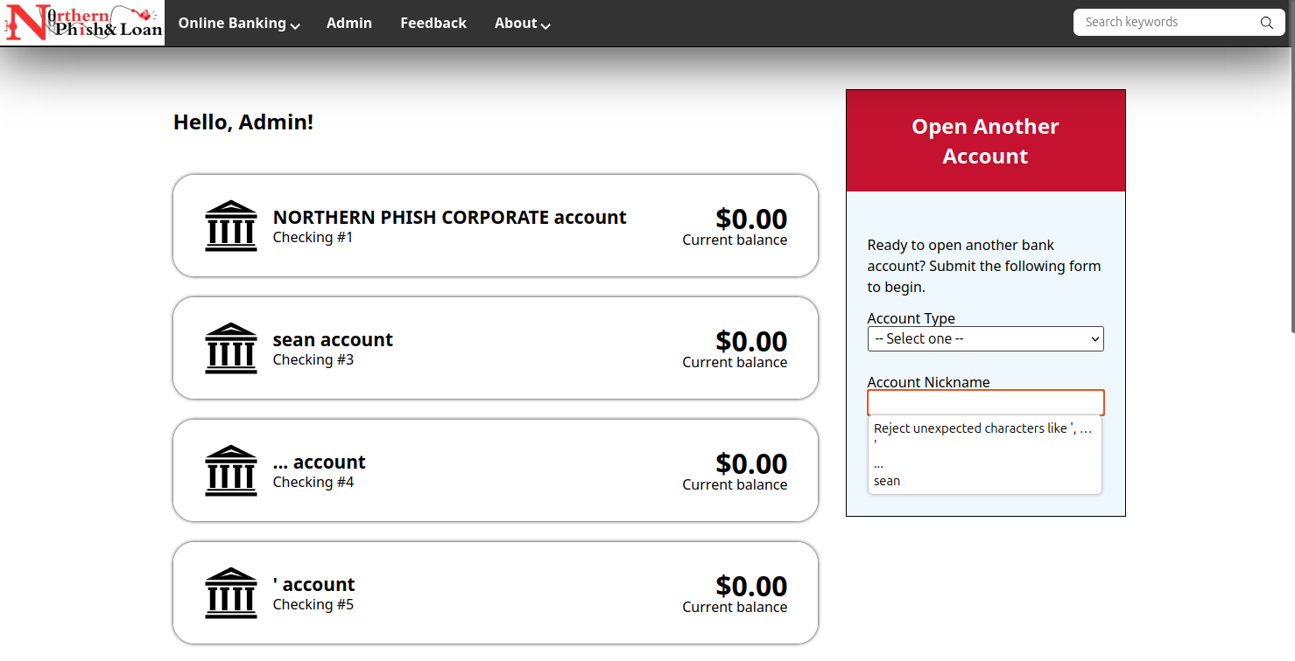
- 4. OWASP Category (with link) A06 Insecure Design – 2025 A04 Insecure Design - 2021
5. CWE ID (with link) CWE-200 CWE - CWE-200: Exposure of Sensitive Information to an Unauthorized Actor (4.19.1)
6. Real-World Impact Scenario - A real-world impact of this would be accounts not known by the attacker can now be known. This gives the attacker more accounts, they didn’t know about to target and misuses now.
7. Risk Severity - Very high, unknown accounts are secretly shown. This now gives the attacker the ability to attack or misuse these accounts.
8. Mitigation Strategy - The nickname search field design should be adjusted to where nicknames of accounts are not revealed by double clicking the nickname field.

9. Sources / References - OWASP Top 10:2021 OWASP Top 10:2025 CWE - CWE List Version 4.19.1

Administrator “Edit Users” Hidden Feature

When on the Administrator account, click on “Admin” tab,
This will take you to the page below.
Click on “Users” to edit Users from admin side.
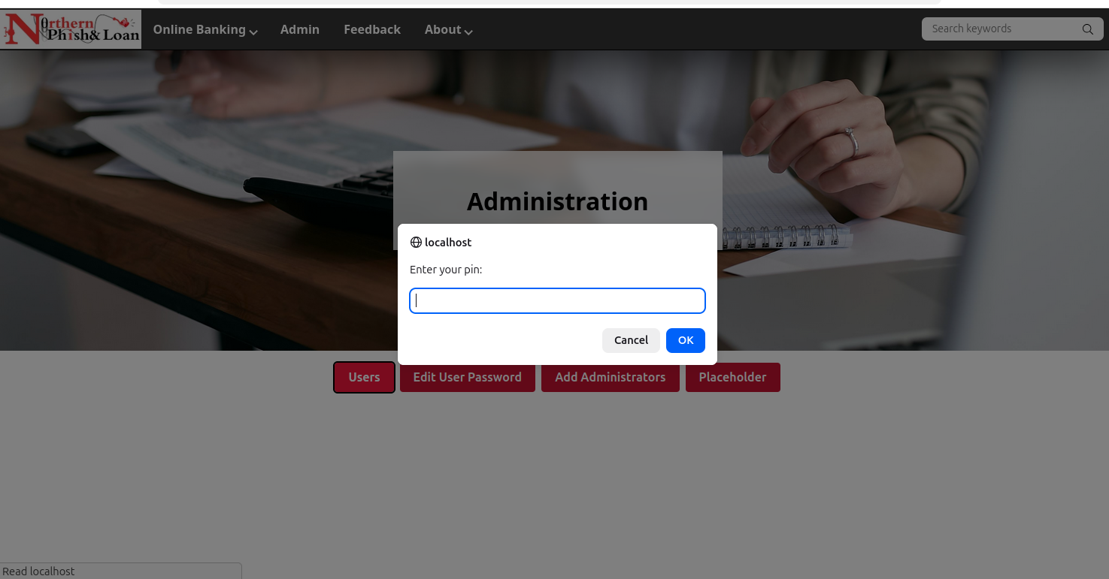
Typing in an incorrect pin shows this.
